Fall 2020 Student Enrollment Packet
To Enroll for ABC Classes, 4 Things are Needed:
- ABC Enrollment Form (Attached)
- Stark State College Admission Application (Attached)*
- Stark State College FERPA Release Form (Attached)*
- Fill out Transcript Release Form (Attached) or High School and College Transcripts or GED must be sent to:*

Mr. Scott Giesler, VP of Workforce Development
ABC- Northern Ohio Chapter
9255 Market Place West
Broadview Heights, Ohio 44147
Email: scottg@nocabc.com
Fax: 440-746-0417
*Electrical, HVAC, and Plumbing students need all four requirements to enroll*

As a student in the ABC Construction Training Program taking Electrical, HVAC, or Plumbing, you are eligible to earn 30 college credit hours, about half of an Associate Degree, at no additional cost to you. You will earn college credit for each level.

The total of 30 hours is the equivalent of over $5,000.00 in college tuition at no additional cost! You can finish the Associate degree online or on campus at Stark State College in Canton; or you can transfer the credit to another college that may be more convenient. Not interested in attending college? You can still receive the credit at no cost to you by simply following the above steps.

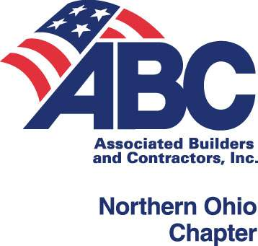
ABC Construction Craft/Apprenticeship Program
Fall 2020 Enrollment Form
Early Bird Savings Thru July 31st. Save $350 with Full Tuition Payment!

Check Trade Choice: ___Carpentry (BH,F) ____Electrical(BH,F,T) ____HVAC(BH) ____ Plumbing(BH)

Level: ______ only indicate LEVEL if you have been given credit hours for a Level 1 class.

Location (check one): ______Broadview Hts. ______Fostoria ______Toledo

Name: _____________________________________________________________________

Address: ___________________________________________________________________

City: _____________________________________________ Zip: _____________________

Cell Phone: _____________________________ Provider/Carrier : ____________________

Email: _________________________________ SSN: .

EMPLOYER: ________________________________

Employer Address: ___________________________________________________________

City: _____________________________________________ Zip: ______________________

Employer Phone No: ___________ Fax No._____________ Email: ___________________

Registrant Type: Save $350 by Paying Tuition in Full No Later than July 31, 2020
ABC Member Company Employee, Part-time, Self-pay or Unemployed
Early Enrollment
Level 1* ______$2,280 $ 1,930

Levels 2-4 ______$2,210 $ 1,860
Non-Member Company Employee (Please consider membership)
Level 1* ______$2,940

Levels 2-4 ______$2,870
All students enrolled in the ABC Electrical, Plumbing, or HVAC Programs can receive college credit of up to 30 hours toward an Associate Degree with no additional tuition, class attendance, or testing required a $5,000+ value!
____ Please send college credit information
____ Please send the ABC Apprenticeship Registration Packet (Enrollment in classes does not automatically register the student as an Apprentice)

Payment Method
___ Please send payment plan ($800 down payment due at start of class)
Check: Submit with this form and mail to the address below.

Credit Card:
Type (Circle): MC/Visa/Disc. Card Number: ______________________ Three-digit code: ____

Name as it appears on Card: __________________________________ Exp: _______________

Authorized Signature: ___________________________________________________________
